Ian Camire

00325798

CIS 245 B1A

Linux Administration - GrepLab

1. Print all lines containing the string Lane

**Grep ‘Lane’ GrepLab.txt**

Search through the file for any instance of the pattern within the single quotes (‘Lane’)

The quotes (‘) tell grep to search for the pattern Lane

from StackOverflow.com comment by knittl

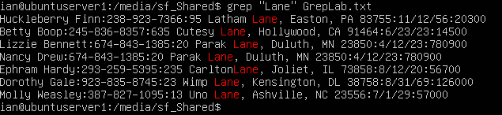

1. Print all lines where the persons first name starts with H

**Grep ‘^H’ GrepLab.txt**

Search through the file for any instance of the pattern within the single quotes (H)

The ^ character is a regular expression to indicate the start of a line

Search through the file GrepLab.txt for any line that begins with (the ^ character) the letter H

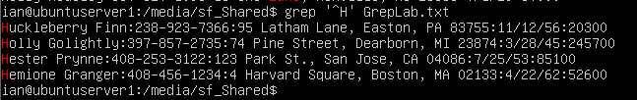

1. Print all lines ending in three 0’s

**Grep ‘000$’ GrepLab.txt**

Grep ‘000$’ The quotes tells grep the pattern to search for

000$ The three zeros are the pattern for grep to search for

The $ is a regular expression to indicate the end of a line

stackexchange.com by jordanm

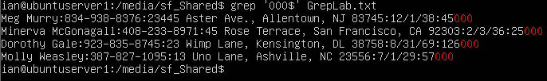

1. Print all lines that do not contain 408

**Grep -v ‘408’ GrepLab.txt**

Grep -v tells grep to invert the search, or search for lines that do not contain the pattern

‘408’ the quotes tells grep what the pattern is

Search through the file for lines that do not contain the pattern of 408

Grep -v : prints all lines that do not match the pattern

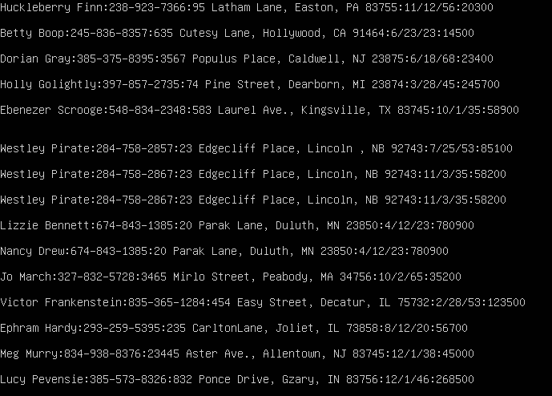

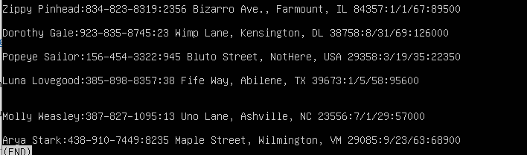

1. Print all lines where birthdays are in the year 1935 from the MM/DD/YY format

**Grep ‘**/**/35’ GrepLab.txt**

Search through the file GrepLab.txt for the pattern of **/**/35

‘**/**/35’ is the pattern to search where * represents a wildcard that can be any character

**/**/35 is the date format where its searching for any MM/DD/ followed by the year 35 (1935)

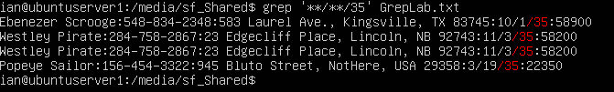

1. Print all lines where the phone number is in an area code that starts with an 8

**Grep :8[0-9][0-9]- GrepLab.txt**

Search through the file GrepLab.txt for the pattern :8[0-9][0-9]-

:8[0-9][0-9]- this looks for the pattern :8 followed by two instances of any number from [0-9]

The area codes in the text file all follow the pattern :***-***-**** so by searching for the : followed by 3 numbers and ending with a – will give me the area codes that start with 8

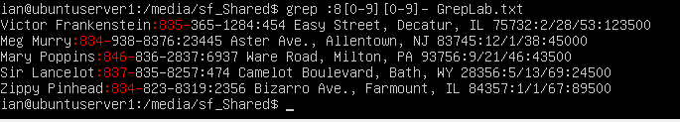

1. Print all lines containing an uppercase letter, followed by 4 lowercase letters, a space and one uppercase letter

**Grep [A-Z][a-z][a-z][a-z][a-z]’ ‘[A-Z] GrepLab.txt**

[A-Z][a-z][a-z][a-z][a-z] the first [A-Z] represents any uppercase letter, the [a-z] represent any four lower case letters

’ ‘[A-Z] the ‘ ‘ show that there is a blank space followed by any uppercase letter [A-Z]

Grep then searches for any line that follows that pattern

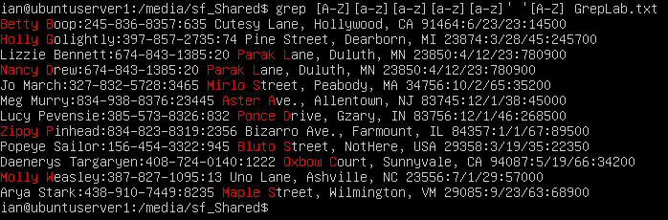

1. Print lines where the address begins with a two or three-digit number

**Grep -e :[0-9][0-9]’ ‘[A-Z] -e :[0-9][0-9][0-9]’ ‘[A-Z] GrepLab.txt**

Search through the file GrepLab.txt for the pattern (-e tells grep to search for the first pattern) :[0-9][0-9]’ ‘[A-Z] the first -e tells grep to search for the pattern of a : followed by any 2 numbers [0-9][0-9] followed by a blank space ‘ ‘ and finally any upper case letter [A-Z]

This pattern represents the street number, the : followed by any two numbers (street numbers) and a ‘ ‘ followed by an uppercase letter (to represent the beginning of the Address which is always capitalized.

The second -e acts as an OR statement

The second pattern is the same as the first but with an additional [0-9] to make grep search for any two digit number OR three digit number that fits the pattern.

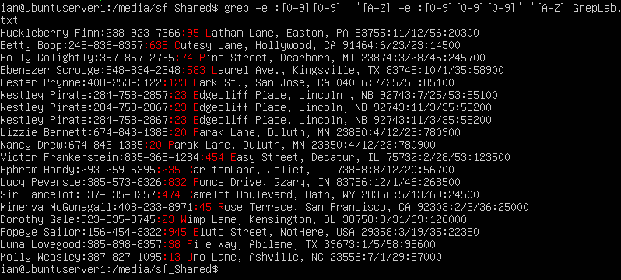

1. Print the lines where the person lives in Mass or Illinois

**Grep -e ‘MA’ -e ‘IL’ GrepLab.txt**

The first -e tells grep to search for the pattern MA (Massachusetts)

The second -e acts as an OR statement and searches for the pattern IL (Illinois)

The result is grep searches for any line that contains MA or IL

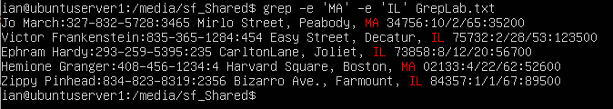

1. Print the lines containing the addresses that aren’t on a street

**Grep -v -e ‘St.’ -e ‘Street’ GrepLab.txt**

The first -e tells grep to search for any instance of the pattern St.

The second -e acts as an OR statement and tells grep to search for any line that contain either St. or Street

The -v modifies both -e statements and tells grep to search for any lines that do not contain the patterns

